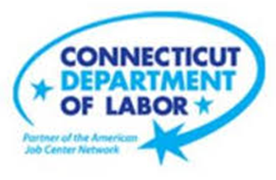

**NEW WEEKLY JOB POSTINGS FROM   
HELP WANTED ONLINE  
Office of Research**

**Week Ending January 29th, 2022:   
New Ads down over the Week But Remain Higher Than A Year Ago.**  
WETHERSFIELD, February 4th, 2022 – During the week ending January 29th, 2022, there were 6,137 new postings, down 2,413 ads over the week. This new ad change is the third largest over the week decline since July 2021 and is shown in the graph below to follow a 26.2 percent increase during the week ending Jan 22nd. Corresponding US-level shifts of the past two weeks include a 12.2% increase followed by a 12.9% decline. Half of this overall shift occurred in Health Care & Social Assistance (-582 new ads), Retail Trade (-483 new ads), or Professional, Scientific, & Recreation (-168 new ads). Employers with the largest over the week decline include Amazon, Hartford Healthcare, and Yale-New Haven Health System. Though down from levels seen during the second half of 2021, the monthly average for weeks ending in January 2022 (6,745 weekly average) is much higher than corresponding levels in January 2021 (4,206 weekly average) and January 2020 (5,073 weekly average), the month before the pandemic began to substantially impact the world economy.  
  
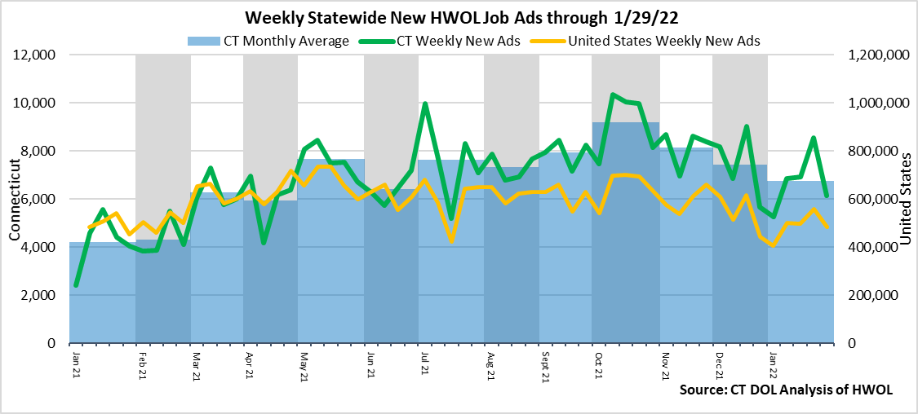

**Industries** with the most new postings include Health Care & Social Assistance, Retail Trade, and Finance & Insurance.

**Occupations** with the most new postings include Registered Nurses, Laborers & Material Movers, and Wholesale & Manufacturing Sales Representatives.

**Employers** with the most new postings include Amazon, Hartford Healthcare, and Capital One.

**The three industries with the most new job postings where:**

* **Health Care & Social Assistance** (1,177 new postings, -33% over the week)
* **Retail Trade** (864 new postings, -36% over the week)
* **Finance & Insurance** (649 new postings, -14% over the week)

   
 18 sectors had job posting decreases over the week, one was unchanged, and 3 had increases. The 18 decreasing sectors fell by a combined 2,429 and the 3 increasing sectors grew by 7 new ads or less. The decreasing sectors all fell by 10% or more over the week, and 7 of 18 had percent declines larger than the total decline of -28%. At the three-digit industry level, the largest over the week declines occurred at NAICS 454 – Nonstore Retailers (down 217 to 433 new ads), NAICS 541 - Professional, Scientific, & Technical Services (down 211 to 241 new ads) and NAICS 622 - Hospitals (down 163 new ads to 448). The industry change over four weeks was less negative, most industries had increases from the week ending January 1st. The largest increase over four weeks occurred in Manufacturing (+228 new ads or +82%) and the largest decrease over four weeks occurred in Accommodation & Food Services (-86 new ads or -25%).  
  
 For more information on total job ads by industry for Connecticut and its labor market areas, see the monthly report available here: <https://www1.ctdol.state.ct.us/lmi/hwol.asp>

**New Job Postings by Occupation** 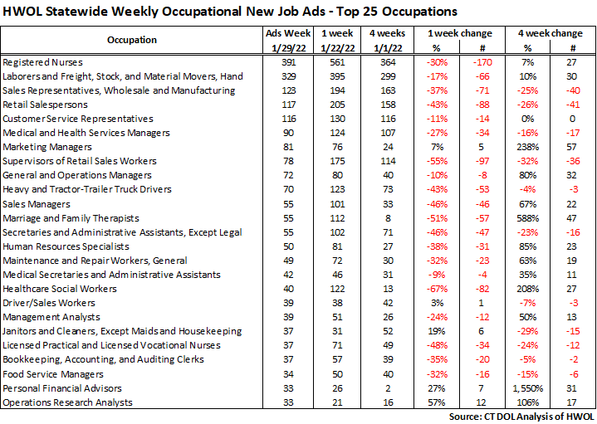

**The occupations with the most new postings were:**

* Registered Nurses (391 new postings, -30% over the week)
* Laborers, Freight, and Material Movers (329 new postings, -17% over the week)
* Sales Representatives, Wholesale & Manufacturing (123 new postings, +37% over the week)

**Employers with the Most New Job Postings** 

Employers with the most new job postings during the week were mostly in Health Care & Social Assistance, Finance & Insurance and Retail Trade. The 25 employers shown above account for 26 percent of all new ads. Among the top 25 employers, 13 had over the week ad decreases, 3 were unchanged, and 9 had increases. The 13 decreasing employers had a combined 1,171 new ads, and the 9 increasing employers in the top 25 had a combined 191 new ads. The largest increasing employers over the week were Boehringer Ingelheim and Lee Enterprises (both +41 new ads), and the largest decreasing employer was Amazon (-319 new ads). Over four weeks, 21 employers in the most recent top 25 had increases and 4 employers decreased, the largest increase occurred at Hartford Healthcare (+184 new ads) and the largest four-week decrease occurred at Amazon (-56 new ads).

**What is HWOL?**The **Conference Board Help Wanted Online**® Data Series (HWOL) measures the number of new, first-time Online job postings and jobs reposted from the previous month for over 16,000 Internet job boards, corporate boards and smaller job sites that serve niche markets and smaller geographic areas. To view more HWOL data, go to: <https://www1.ctdol.state.ct.us/lmi/HWOL2021.pdf>